Software Requirements Specification

for

Warehouse Management System

Version 1.1 approved

COMPC 13 – Ashutosh Sharma

COMPC 14 – Jayesh Sharma

COMPC 16 – Vinit Sharma

COMPC 18 – Karthik Shetty

Thakur College of Engineering and Technology

Date: 09/02/2023

Table of Contents

Table of Contents 2

Revision History 2

1. Introduction 3

1.1 Purpose 3

1.2 Document Conventions 3

1.3 Intended Audience and Reading Suggestions 3

1.4 Product Scope 3

2. Overall Description 4

2.1 Product Perspective 4

2.2 Product Functions 4

2.3 User Classes and Characteristics 4

2.4 Operating Environment 4

2.5 Design and Implementation Constraints 5

2.6 User Documentation 5

2.7 Assumptions and Dependencies 5

3. External Interface Requirements 5

3.1 User Interfaces 5

3.2 Hardware Interfaces 5

3.3 Software Interfaces 5

3.4 Use Case Diagram 5

4. System Features 6

4.1 Response Sequences 6

4.2 Functional Requirements 6

4.3 Admin Module (Data management System) 6

4.4 Sales Manager Module (Counter system) 6

4.5 Warehouse Manager Module (warehouse management system) 7

4.6 Payment module (billing system) 7

4.7 Customer module (customer management system) 7

5. Other Nonfunctional Requirements 7

5.1 Performance Requirements 7

5.2 Safety Requirements 7

5.3 Security Requirements 7

5.4 Software Quality Attributes 8

6. Other Requirements 8

Appendix A: Glossary 8

Appendix B: Analysis Models 8

Appendix C: To Be Determined List 8

Revision History

|  |  |  |  |
| --- | --- | --- | --- |
| **Name** | **Date** | **Reason For Changes** | **Version** |
| Updating the Use Case Diagram | 16th March 2023 | Some parameters were missing | 1.0 |
|  |  |  |  |

# Introduction

## Purpose

The “Ware House Management System” aims to reduce the paper work, financial expenses and provides the real time performance to the user in a more manageable way. It is the act of organizing and controlling everything within warehouse and make sure that it runs in the most optimal way possible.

This includes:

* Arranging the warehouse and its inventory.
* Having and maintaining the appropriate equipment.
* Managing new stock coming into the facility.
* Picking, packing and shipping orders.
* Tracking and improving overall warehouse performance.
* Most high growth retailers would use automation tools to control this part of their supply chain

## Document Conventions

* Times New Roman font style is selected throughout the document.
* Chapter headings sized is fixed to 18
* Normal and sub-headings are set to 14.
* Text sized is fixed to 12
* Paper size is set to A4
* All headings are in Bold.

## Intended Audience and Reading Suggestions

This SRS will lead the development team’s members specially:

* Designer
* Tester
* End User
* Project Manager to implement the customer’s need that lead the project to be successful. This SRS is organized according to the IEEE’s format. Moreover, this will be a legal contract between the client and development organization.

## Product Scope

The WHMS is responsible for maintaining registered items, their quantities and alarming the manager and admin at lower stock. Moreover, it will be able to have a good check and balance in the all branches associated with this system. This system also helps to keep the track of the picking, packing and shipping of orders. This system will be a great deal for the owner and his/her customers and worker to perform their jobs in a very efficient way. This will be applicable to the all stores having daily life’s needed items. Thus it is a generic system.

# Overall Description

## Product Perspective

Most of the warehouse management system available in the market does not cater for all the requirements such as shipment tracking and monitoring. Warehouse owners have to use different applications for management. Moreover, some systems have interfaces which are difficult to navigate. WHMS also helps the clients in reducing the paper work generated for each transaction. As the resources are managed electronically the chances of human error is reduced which allows the resources t--o be used efficiently.

## Product Functions

The system will allow the users to:

* Allow admin to add and remove customer, manager, dealer and supplier, generate report, view stock, and to check in and out transactions.
* Alarms the manager and admin on low stock of the items
* Generate auto bills through barcode reader.
* Keep track of in and out items.

## User Classes and Characteristics

The following users will interact with the WHMS according to their goals:

* Admin: He/she has complete control over the system. They can add and remove customer, manager, dealer, and supplier, generate report, view stock, and to check in and out transactions.
* Ware House Manager: Report to the admin on admin’s demand manually and report regularly to the admin on each month.
* Ware House Worker: Add and subtract the quantity available when new shipment arrives or cargo leaves the warehouse.

## Operating Environment

This system is a web application and can be operated on any online resource that resource internet.

The minimum requirements for system are:

* Quad core processor of 1.0 GHz minimum
* 4 GB of RAM and 512 MB or free RAM at the time of use
* ROM can be HDD or SSD
* Minimum 1GB of Disk Space

External storage for database will not be required as the data is stored in the cloud.

## Design and Implementation Constraints

* The system will use non-relational database.
* It will employ a modular approach
* All the user requirements will be documented before the start of the project
* The project team will communicate with the client and the production of new module will begin only after the current version is evaluated.
* Industry standards will be maintained during development

## User Documentation

* User manual for system introduction
* Training Guide for end user and warehouse manager.

## Assumptions and Dependencies

All the requirements all well-defined and the developer will not make any assumption. If the developers are not clear on any requirements they must report to the Requirements Engineer before proceeding.

# External Interface Requirements

The design of interfaces should be more efficient, improved user experience, reduced costs, enhanced accuracy, greater customer satisfaction and easy to be used by the system users.

## User Interface

The user interface should be intuitive and easy to use to minimize errors and training time for new users. The interface should provide a clear overview of the warehouse’s inventory including stock level, location and movement history. The interface should allow users to search products or items easily. The interface should be able to display real time data on the inventory movements and status. It should allow users to create and manage orders, including receiving, picking, packing and shipping. It should provide reporting and analysis tools to monitor and optimize the performance of the system.

## Software Interfaces

Operating System: No constraints for operating system as it is a web based application

Database: MongoDB 6.0

Libraries: React 18.0.1, Bootstrap 5.1

Tools: Figma 9.0, Visual Studio Code 1.75

## Hardware Interface

* It should be compatible with the software used by the WMS (warehouse management system).
* It should be able to read and write data to the inventory management system efficiently and accurately.
* It should be durable and capable of withstanding the demands of the system.
* Common hardware interface used in a WMS (warehouse management system) include barcode scanner, mobile devices, label printers, RFID readers and conveyor system.

## Use Case Diagram

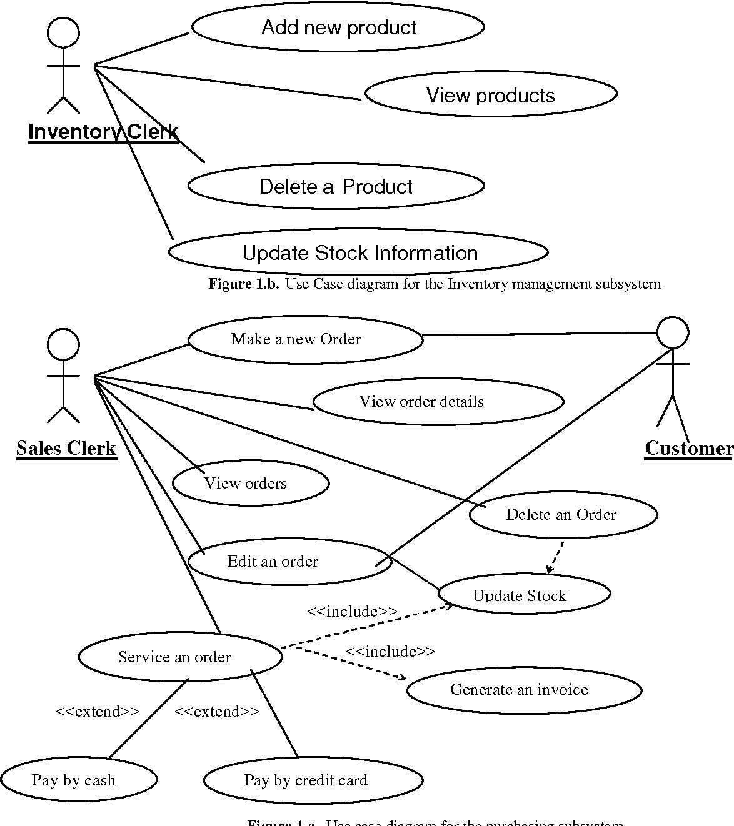

**Use Case Diagram for Warehouse Management System**

# System Features

It will include the following features:

## Response Sequences

For the admin and any other user to perform any action he must have a valid login that

provided by this system. After Successfully login each user will perform his corresponding

functions.

## Functional Requirements

* + - Provide list of product sale on the last day of month
    - List is provided from every store
    - Capable of handling large inventory
    - Capable of in and out transections
    - Manage stock in and out list
    - System should give notification of low stock

## Admin Module (Data management system)

The system allows admin to perform the following task.

* + - Add Products
    - In & Out Transactions
    - Add Supplier
    - Add Dealer
    - View Supplier/Dealer
    - View Transactions
    - Monthly Report
    - View Stocks

## Sales Manager Module (Counter system):

The system allows Sales Manager to perform the following task.

* + - In & Out Transactions
    - View Stocks
    - Check for discount
    - Issue bills
    - Reads Barcode for price detection

## Warehouse Manager Module (warehouse management system)

The system allows Warehouse Manager to perform the following task.

* + - * In & Out Transactions
      * View Supplier/Dealer
      * View Transactions
      * Monthly Report
      * View Stocks

## Payment module (billing system)

* + - * Communication with banks
      * Transaction
      * Generate bills

## Customer module (customer management system)

* + - * Add customer
      * Register as verified/permanent
      * Check customer
      * Keep track of purchase
      * Send data

# Other Nonfunctional Requirements

## Performance Requirements

WHMS is a real time web based system. The system shall be able to respond to the user initiated actions in a real time environment. The change of view state of an action should not take longer than 5 second. The Database should strictly follow the ACID properties. Doing so the Database will remain in a valid state even in case of occurrence of an unexpected error.

## Safety Requirements

The Data saved in the management system should remain save in case of any un-conditional environment like fire, earth quake etc. there should be a backup and disaster in order to get back the system’s data. A backup of Data stored in the database should be maintained, which will be done using cloud computing.

## Security Requirements

The WHMS will be available only to the authorized users of the company. In addition to this, the web-application should strictly adhere to the Open Web Application Security Project guidelines.

## Software Quality Attributes

### Usability

WHMS must be very easy to use. The UI of the web-application should be non-technical user friendly and quite dynamic.

### Portability

WHMS will be able to use all versions of the windows operating system.

### Reliability

There should be no space for error, if a user makes some mistake then a catch and throw should handle the errors. In addition to this an alert message should be displayed on the screen. The system should be able to continue to perform all others actions even if one module is affected.

### Flexibility

WHMS will be able to add new franchise if admin wishes to open a new branch in a city. WHMS will also be responsible to maintain the newly opened franchise.

Appendix A: Glossary

WHMS - Warehouse Management System

AWS - Amazon Web Services

For Faculty Use

|  |  |  |  |  |
| --- | --- | --- | --- | --- |
| **Correction Parameters** | **Formative Assessment [40%]** | **Timely completion of Practical [ 40%]** | **Attendance / Learning Attitude [20%]** |  |
| **Marks Obtained** |  |  |  |